SKILL UP SESSION REPORT
WORKSHOP ON 3D PRINTER
Innovation And Entrepreneurship Development Centre (IEDC) Executive Members conducted a workshop on 3D printer for a limited number of students at Royal College Of Engineering And Technology on 7th and 8th of December 2021 at IEDC room, RCET. The program was coordinated by Mohamed Nihas (CTO IEDC & S7 EEE). The aim of workshop is to familiarize the working and convey knowledge in related to 3D printer.
The number of student attended the session: 35
A brief report of the proceedings during both these days is as follows:
The session was arranged in two days for the maximum utilization
Day 1: The first day session was started from 4:00PM to5:00PM.The Executive team of IEDC welcomed the students in the presence of Nodal Officer DINTO THOMAS(AP OF EEE DEPT) and gave an overall view on the parts and working of 3D printer. Mainly the session was focused on the primary concept of designing, students were provided laptops & students were successfully able to design the subjects under our guidance at the end of that session.
Day 2: Next day session conducted from 4:00PM to 5:00PM.It was a practical session, the code which was designed the day before was converted into G CODE i.e., machine language. Among them one design was printed with the 3D printer & instructed students to utilize this concept for developing Project parts. At the end of the day students were able to familiarize the parts, design and were able to gain printing knowledge in a 3D printer.
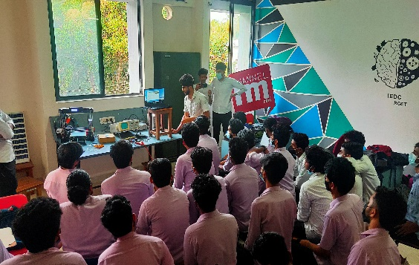 | 